ROUND HILL GENERAL IMPROVEMENT DISTRICT RESOLUTION # 320

A RESOLUTION ADOPTING A RATE INCREASE OF PRESENT SEWER TARIFFS, COMME NCING JULY 1, 2022,

WHEREAS, the Board of Trustees of Round Hill General Improvement have determined that the

User Fees for the Sewer Fund are insufficient, and

WHEREAS, it is the goal for the Board of Trustees of the Round Hill General Improvement District to maintain the Sewer fund self-sufficient, and

WHEREAS, the Round Hill General Improvement District has, pursuant to the requirements of law, given notice of the intention of the Round Hill General Improvement District to increase said rates, and

WHEREAS, on the 28" day of June, 2022, said hearing did take place and all objections, comments and public input was received by the Round Hill General Improvement District Board of Trustees, and

NOW, THEREFORE, BE IT RESOLVED, that the Board of trustees does hereby adopt a rate increase in the District's Sewer Rates as follows:

All residential and commercial customers will incur a base rate sewer increase of 30% on

July 1, 2022.

**MONTHLY RATES-Residential**

**Minimum Rate July 2022**

**Minimum Rate July 2023**

**Minimum Rate July 2024**

**Minimum Rate July 2025**

**Minimum Rate July 2026**

**Metered -- per 1,000 Gallons**

**for water service line size > .75 inch**

**With a minimum of 3,000 gallons per month**

**July 1, 2022**

**July 1, 2023**

**July 1, 2024**

**July 1, 2025**

**July 1, 2026**

**$82.12**

**$90.33**

**$97.56**

**2.9% up to CPI**

**2.9% up to CPI**

**$29.08**

**$29.08**

**$31.99**

**$34.55**

**2.9% up to CPI**

**2.9% up to CPI**

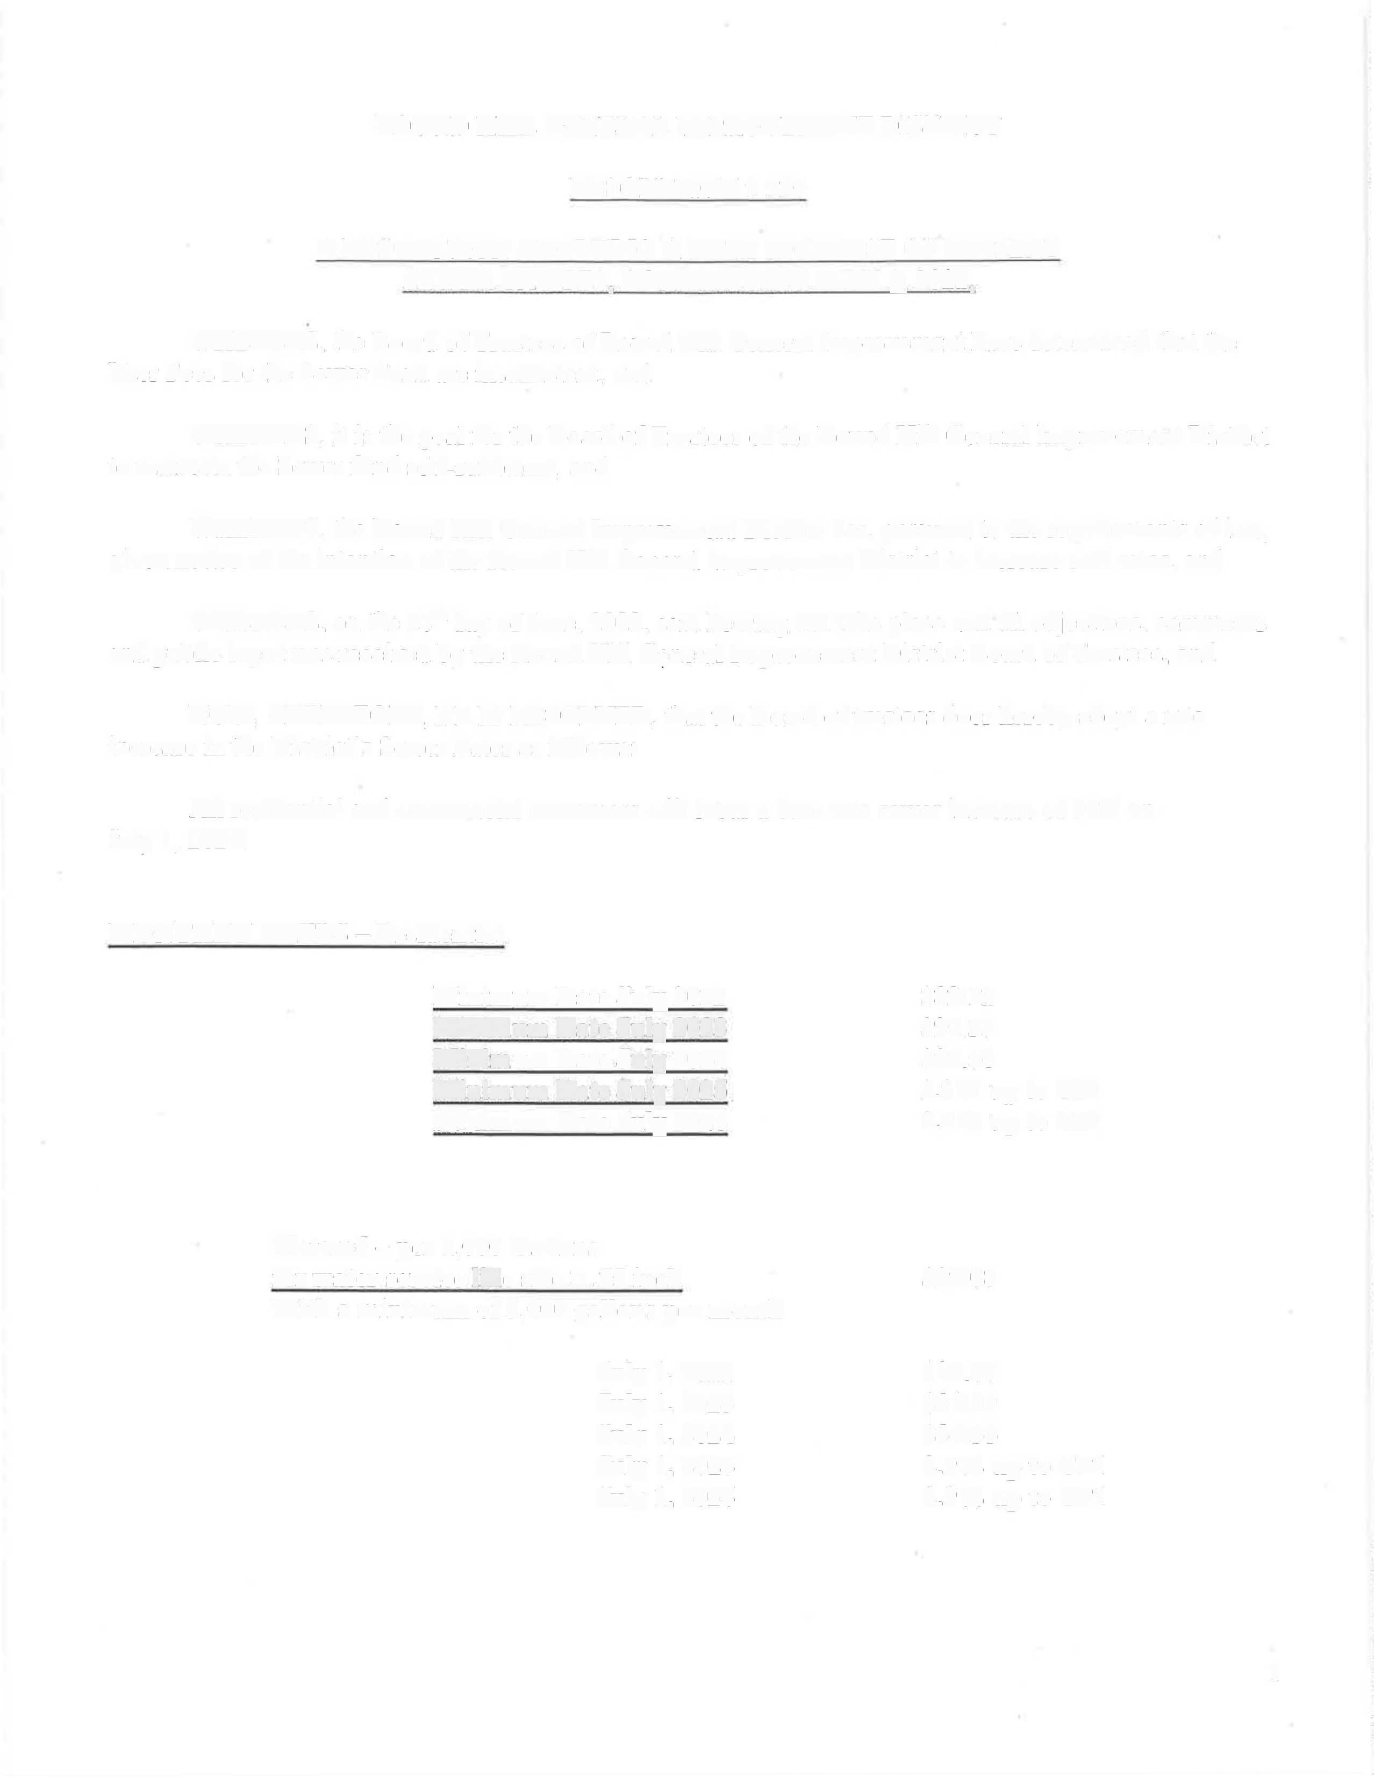

1

MONTHLY RA TE -- Commercial

Metered-per 1.000 Gallons

With a minimum of 3,000 gallons per month

$29.08

July 1, 2022

July 1, 2023

July 1, 2024

July 1, 2025

**July** 1, 2026

**$29.08**

**$31.99**

**$34.55**

**2.9% up to CPI**

**2.9% up to CPI**

PASSED AND ADOPTED this 28" day of June, 2022 by the following vote of the Board of trustees:

AYES: Keith Fertala Chuck Fagen Darin Smith Hunter Harris Gregg Rossi

NAYS: ______________

ABSENT:

DATE

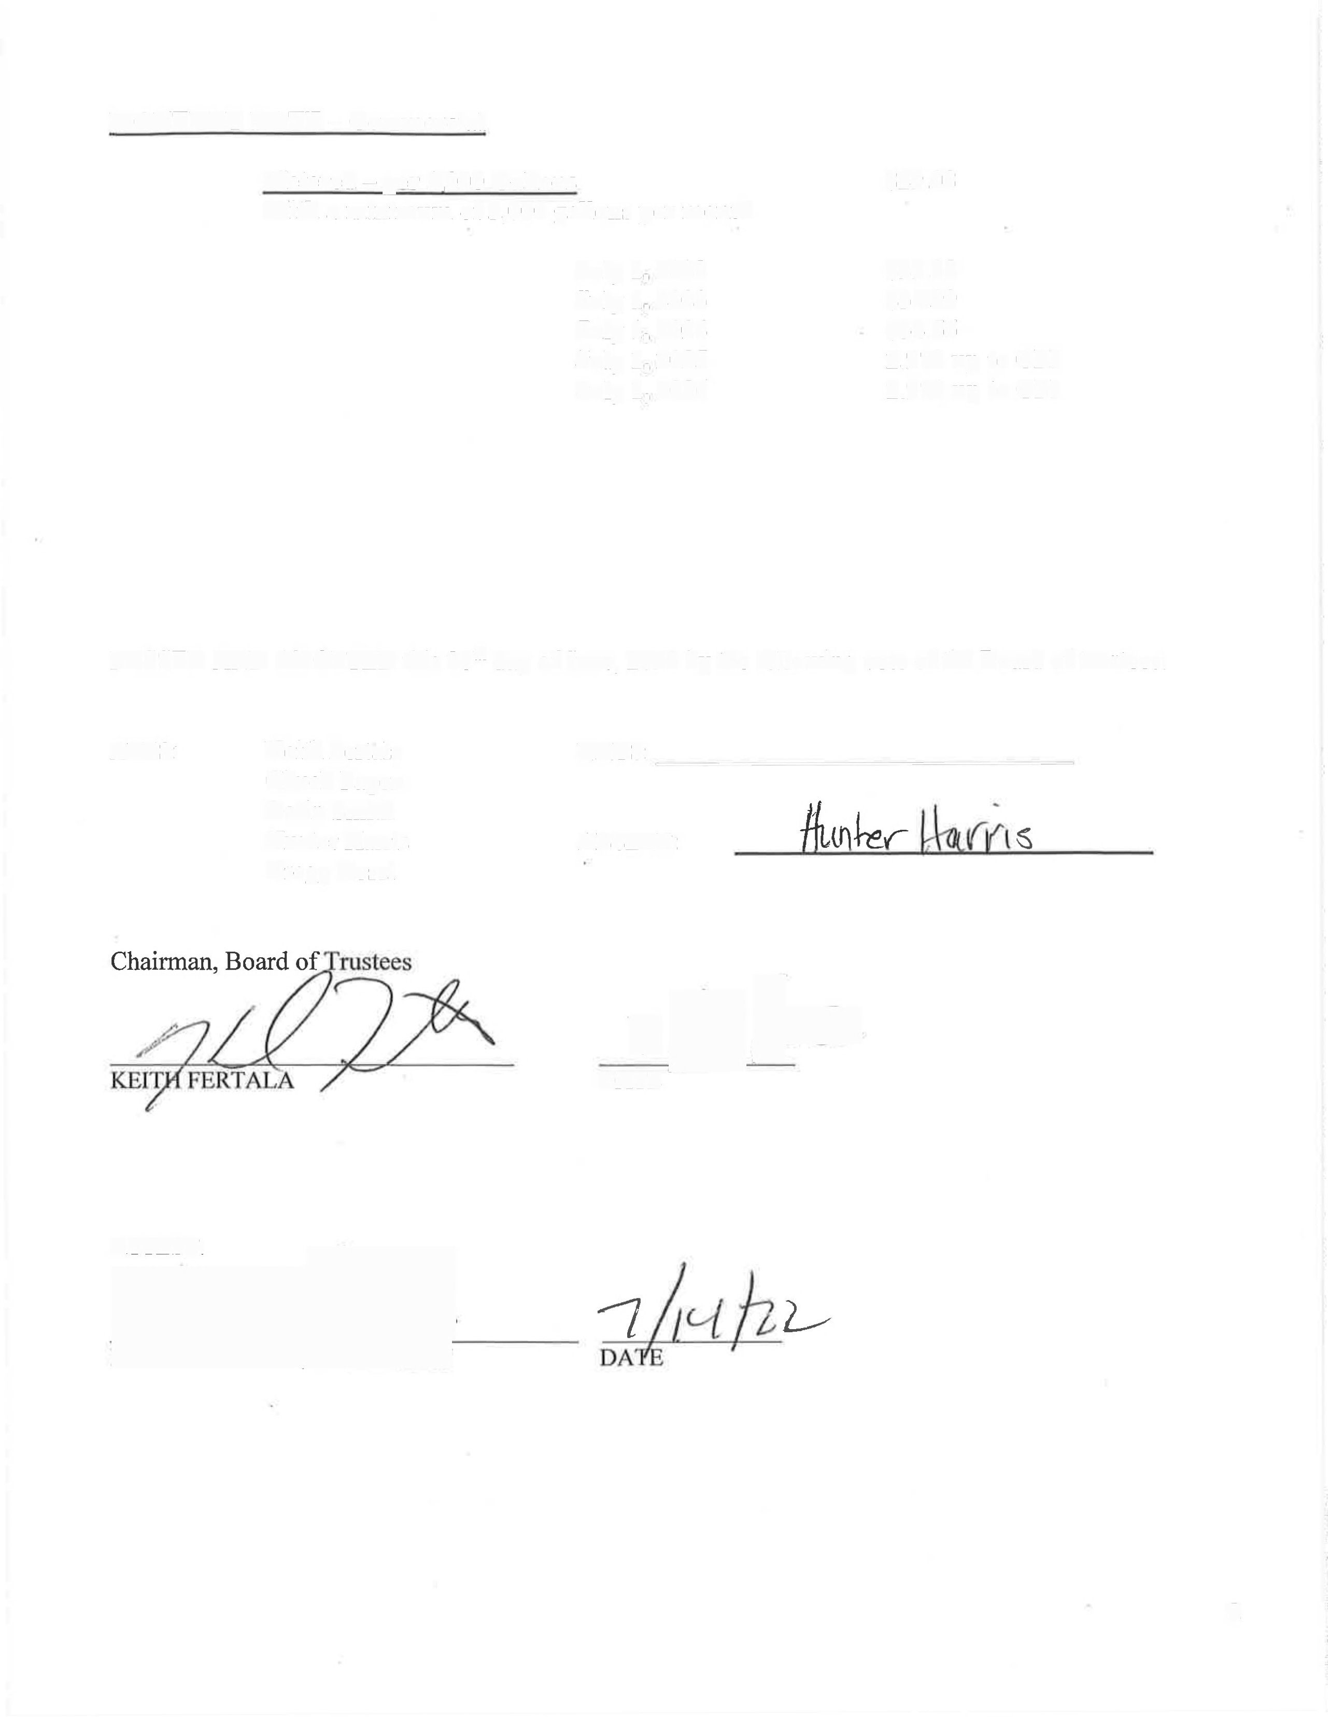

**ATTEST:**

2