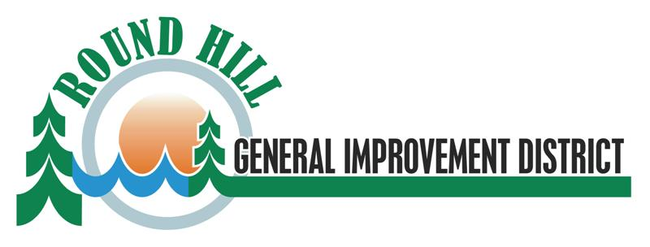

Water Operator

Round Hill GID is looking for a Water Operator. Qualified candidates must have a wide range of skills related to water treatment and distribution. Experience in snow removal a plus. Training will be provided. Wage and classification based on experience/certification. MINIMUM starting wage will be $22.32/hr to $28.74/hr DOE. 100% PERS and insurances (medical/dental/life) paid by District.

Please see our website [www.rhgid.org](http://www.rhgid.org) for application and job description; or call 775-588-2571. RHGID is an equal opportunity provider and employer.

Email completed application to andrew@rhgid.org

Deadline to apply is 07-30-2023.